The Director,
Department of Skill Development,
Jammu and Kashmir.

No: KGP/Estt/2026/ Dated:28-07-2026

Subject: Request for correction/updation of employee details in HRMS.

Sir,
As per mail communication from your office, the information related to the Correction/updation was sought from the Officers/Officials of the institution. Based on the responses received, kindly find below the details of the required corrections/updations along with the old value and the new (correct) value to be processed on the HRMS portal. The necessary supporting documents are also enclosed herewith for ready reference.
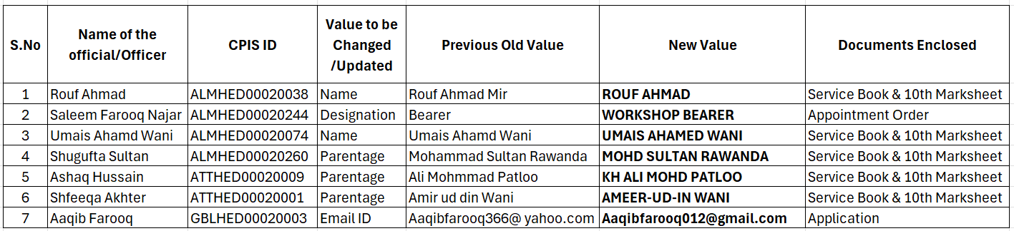

It is therefore requested that the necessary corrections/updation may kindly be carried out in the HRMS of the above-mentioned Officers/Officials.

Yours Faithfully

Principal
Kashmir Government Polytechnic College
Srinagar

Copy to the:
1. Accounts Officer, Department of Skill Development for information. This is based on your official mail communication received by this office.

